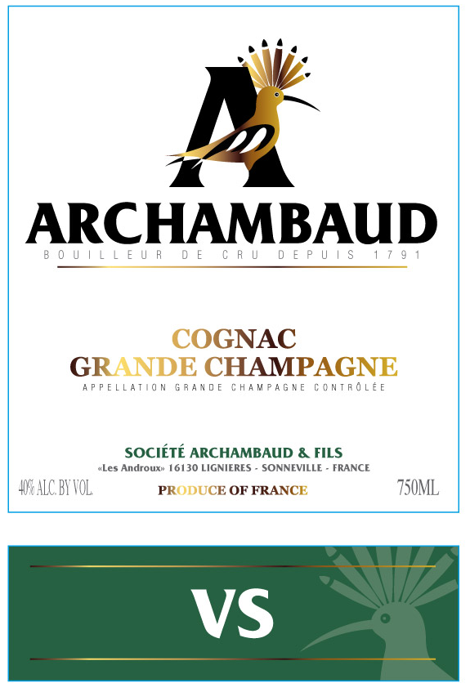

Archambaud Cognac Grande Champagne VS
Johan Archambaud designed this specifically for blending into drinks. Don’t tell him, but we drink it on it’s own just as often.
___________________________________________________________________________________
VARIETIES: 100% Ugni Blanc
CLASSIFICATION: Cognac Grande Champagne VS AOC
VINEYARDS: Estate Vineyards in the Grande Champagne region of Cognac

VINEYARD SOILS: Chalk dominated with sand and clay
ABV: 40.0 %
DISTILLATION: Copper pot still
AGING: This is largely from 2012 with a few older vintages blended in and then a mature cask finish. A higher percentage of new oak was used to accent the freshness with the sweetness of wood. No caramel coloring, additives or chill filtering.

